**Challenge 1**: **List all files (including hidden ones) in your home directory and sort them by modification time.**

**Answer:**

ls -laht ~

**Explanation:**

* ls → List directory contents
* -l → Use a long listing format
* -a → Show hidden files (files starting with .)
* -h → Display sizes in human-readable format (e.g., KB, MB)
* -t → Sort by modification time (newest first)
* ~ → Home directory
* 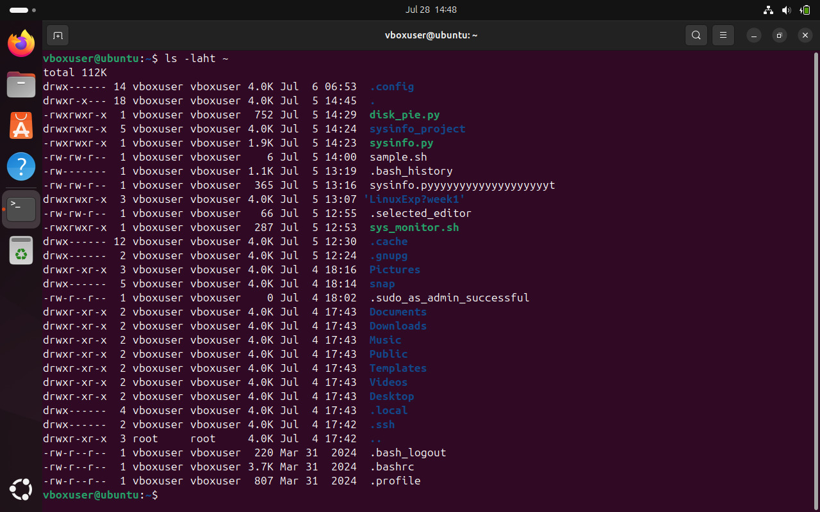

✅ **Challenge 2**: **Create a directory named**devops_challenge_day_1**, navigate into it, and create an empty file named**day1.txt**.**

**Answer:**

# Step 1: Create a directory named devops_challenge_day_1

mkdir devops_challenge_day_1

# Step 2: Navigate into the directory

cd devops_challenge_day_1

# Step 3: Create an empty file named day1.txt

touch day1.txt

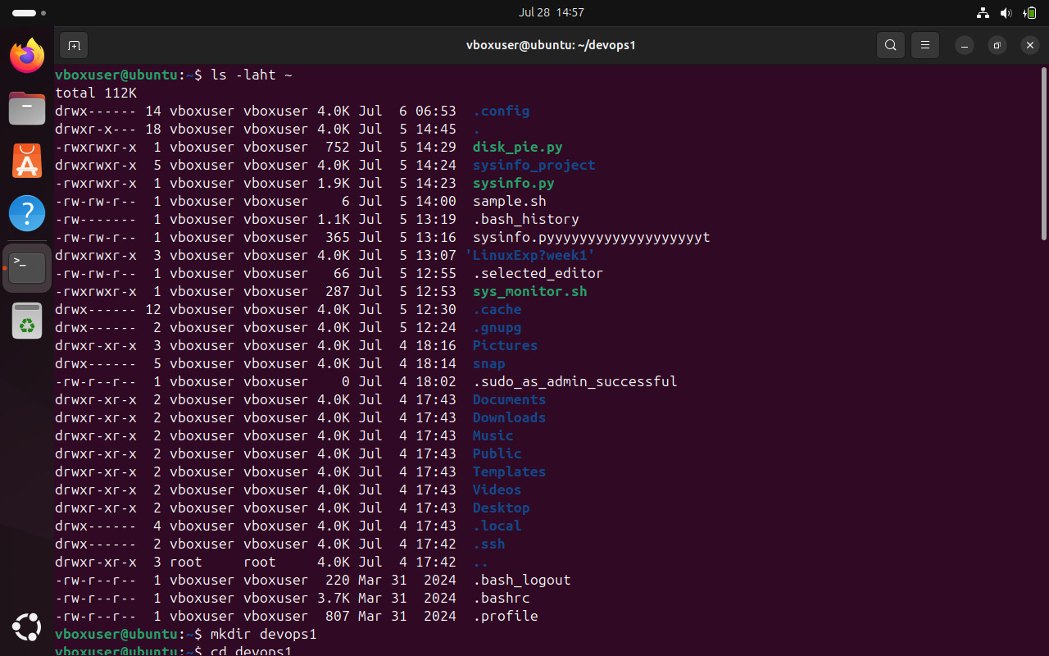

✅ **Challenge 3**: **Find the total disk usage of the**/var/log**directory in human-readable format.**

**Answer:**

du -sh /var/log

**Explanation:**

* du → Disk usage command
* -s → Summarize total size instead of listing all files
* -h → Human-readable format (e.g., KB, MB, GB)
* 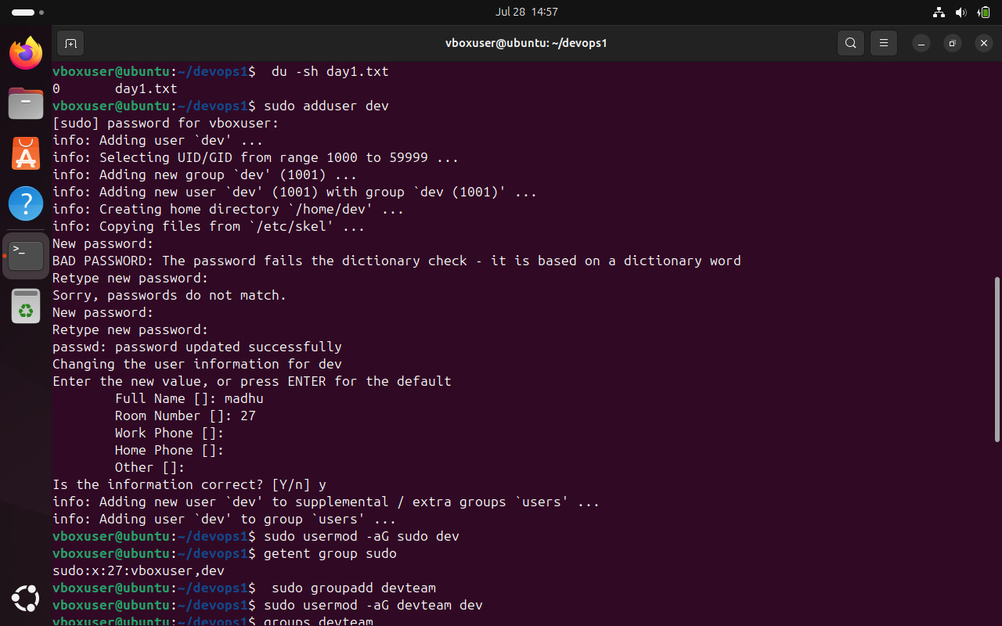

✅ **Challenge 4**: **Create a new user called**devops_user**and add them to the**sudo**group.**

**Answer:**

# Step 1: Create a new user called devops_user

sudo adduser devops_user

# Step 2: Add the user to the sudo group

sudo usermod -aG sudo devops_user

# Optional: Verify the user is in the sudo group

getent group sudo

**Run the below command to verify it:**

id devops_user

**Explanation:**

* sudo useradd -m -s /bin/bash -G sudo devops_user
  + useradd → Creates a new user.
  + -m → Creates a home directory for the user.
  + -s /bin/bash → Sets Bash as the default shell.
  + -G sudo → Adds the user to the sudo group for administrative privileges.
  + devops_user → The username being created.
* sudo passwd devops_user
  + Sets a password for devops_user (you’ll be prompted to enter a password).
  + 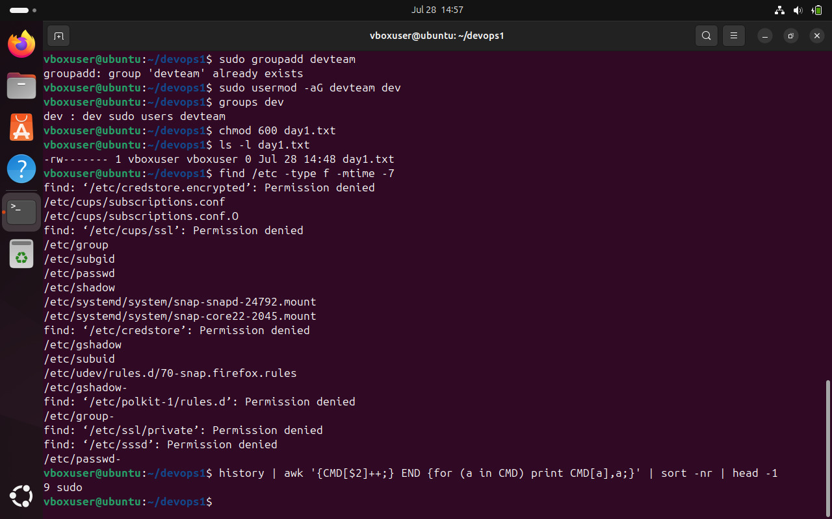

✅ **Challenge 5**: **Create a group called**devops_team**and add**devops_user**to that group.**

**Answer:**

sudo groupadd devops_team

sudo usermod -aG devops_team devops_user

**Verify using the below command:**

groups devops_user

**Explanation:**

* sudo groupadd devops_team
  + Creates a new group named devops_team.
* sudo usermod -aG devops_team devops_user
  + Adds devops_user to the devops_team group.
  + -aG → Appends (-a) the user to the specified group (-G devops_team) without removing them from other groups.

✅ **Challenge 6**: **Change the permissions of**day1.txt**to allow only the owner to read and write, but no permissions for others.**

**Answer:**

chmod 600 day1.txt

**Verify using the command:**

ls -l day1.txt

